**Explanation**

Policy changed on how the company can manually apply adjustments. All adjustments new require management approval before they can be done. The information must be sent out in a very specific format; many of the associates were not complying, so a VBA form was created that formatted the request for the user. The macro was added to outlooks quick access toolbar.

Standard Adjustment input

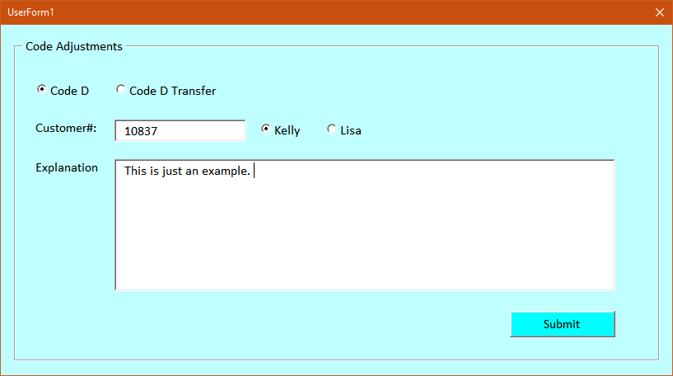

Standard Adjustment Output

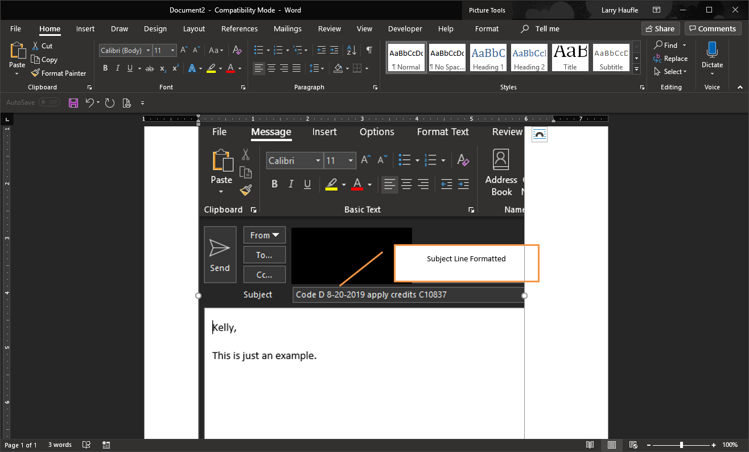

Transfer Adjustment input

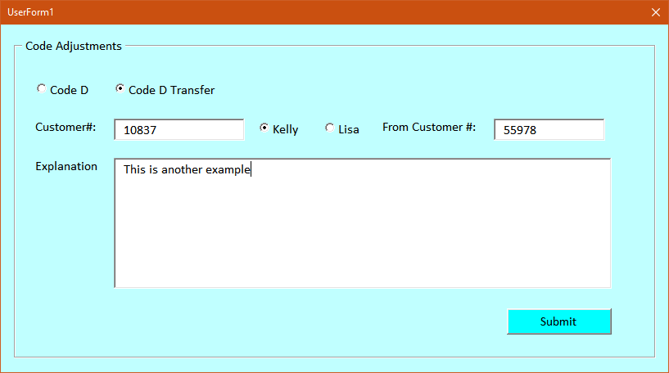

Transfer Adjustment output

